Permeate flow

porous wall

Outlet from annulus

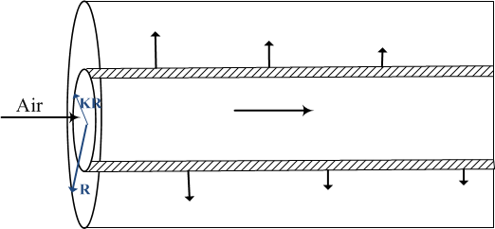

Closed end