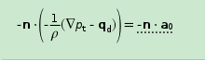

C:\Users\Administrator\AppData\Roaming\Tencent\Users\448489270\QQ\WinTemp\RichOle\FC]TDX3])1JLQMN_O$M[H%6.png