AC analysis of the cantilever
The time steps taken in my previous simulations were not small enough. Hence, the COMSOL could not take enough points to draw the sinusoidal signal.
To solve that problem, I chose smaller time step. Firstly, I only computed with keeping only “Electric Current” module on but keeping rest of the modules off (namely, “heat transfer” and “solid mechanics”).
For a frequency of 100 Hertz, time steps of 0.1 millisecond (100 microsecond) and simulation time of 0.1 second, the input signal is perfectly sinusoidal. (Figure 1)

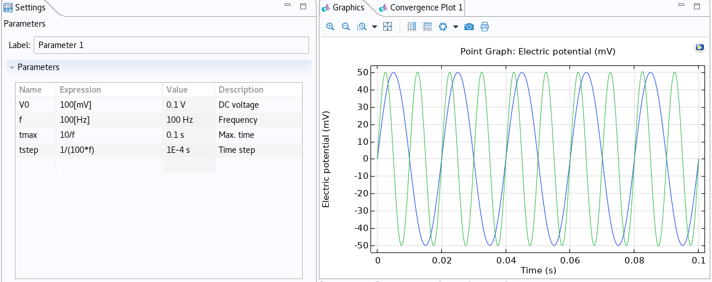
Figure 1

Then, I tried to run the complete simulations with keeping all the modules on (ec, ht, sm). However, this time the input signal is no longer sinusoidal. (Figure 2: green for ω, blue for ω/2).

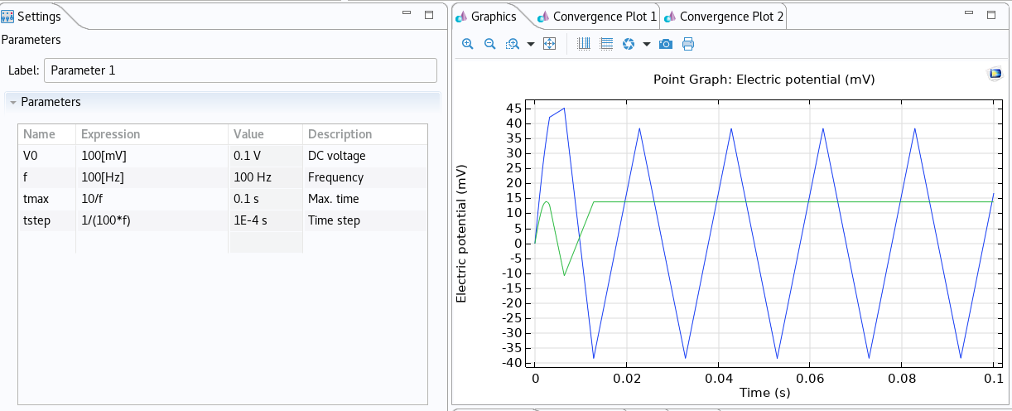
Figure 2

Now, I do not know how to tackle this problem. I hope, you can give me some valuable suggestions.

