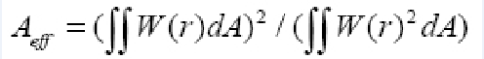
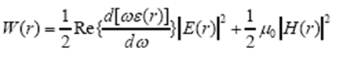
W(r)are the electromagnetic energy and energy density per unit length along the direction of propagation

