the ALE error

Hi,everyone,

I ‘m building a simple model based on the “heat transfer” module and the “ALE” module. The geometry is a simple rectangle. In the heat transfer node, the upper boundary is a heat flux BC, and other three are thermal insulation. In the ALE node, a prescribed normal mesh velocity is implemented on the upper boundary, other three are fixed.
Recently, I have encountered some problems relative to the ALE. Due to this reason, I deactivate the ALE module and solve the model where there is only a “heat transfer” module with some local variable to see where the error and mistake is (to ensure whether there is any wrong variable definition). In the ALE node, a “prescribed normal mesh velocity” is implemented on the upper boundary, where the ”normal mesh velocity Vn” is setting “to roeB_r+rolB_r” (m/s), After solving the model without the ALE, the theoretical normal mesh velocity (I defined a local variable with the expression of “roeB_r+rolB_r” to visualize the variable) is illustrated in the Fig. 1. In the Fig.1, we can see there should be a moving of the boundary.
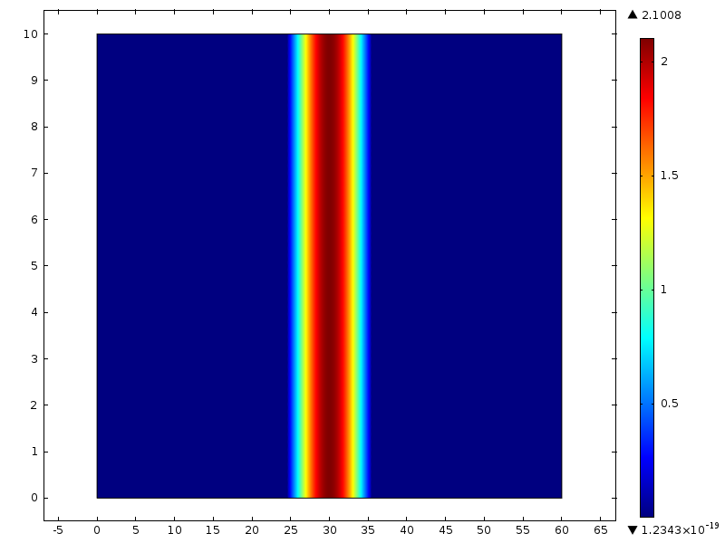
Fig. 1 Theoretical prescribed mesh velocity
But when I activate the ALE node, the following error occurs (also as the Fig.2 shown).

Attempt to evaluate non-integral power of negative number.
- Function: ^
Failed to evaluate temporary symbolic derivative variable.
- Variable: mod1.rolB_r@VDN${mod1.genext1@13}
- Defined as: ((1/(mod1.dB*((unit_m_cf^2)*unit_s_cf)))*((((((((log((mod1.TB/T_m))*(unit_s_cf*(mod1.DB*2)))/(r_0*unit_m_cf))^(-0.5))*0.5)*((1/(r_0*unit_m_cf))*((((((1/(mod1.dB*mod1.hcB))*(((1/(unit_K_cf*unit_m_cf))*unit_W_cf))))*2)*unit_s_cf)*log((mod1.TB/T_m)))))*unit_kg_cf)*((mod1.Pr_sB/unit_Pa_cf)^0.25))*((((unit_m_cf^3)*mod1.dB)/unit_kg_cf)^0.75)))
Failed to evaluate temporary symbolic derivative variable.
- Variable: mod1.ale.vn@VDN${mod1.genext1@13}
- Defined as: (((1/(mod1.dB*((unit_m_cf^2)*unit_s_cf)))*((((((((log((mod1.TB/T_m))*(unit_s_cf*(mod1.DB*2)))/(r_0*unit_m_cf))^(-0.5))*0.5)*((1/(r_0*unit_m_cf))*((((((1/(mod1.dB*mod1.hcB))*(((1/(unit_K_cf*unit_m_cf))*unit_W_cf))))*2)*unit_s_cf)*log((mod1.TB/T_m)))))*unit_kg_cf)*((mod1.Pr_sB/unit_Pa_cf)^0.25))*((((unit_m_cf^3)*mod1.dB)/unit_kg_cf)^0.75))))
Failed to evaluate expression.
- Expression: d(d(((mod1.ale.xt_free*mod1.ale.nx+mod1.ale.yt_free*mod1.ale.ny-mod1.ale.vn)*test(-x_lm))*(dvol),{test@0}),{mod1.genext1@13})

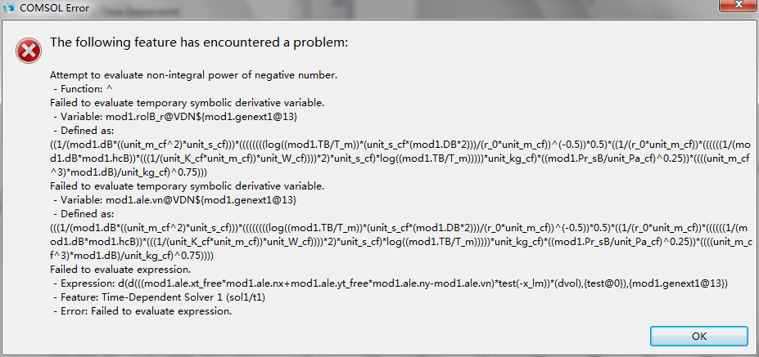
Fig. 2 The non-integral power of negative number error

I’m quite puzzled about that, I can solve the model and evaluate all the relative variables without the ALE. This means there is no any wrong with the parts except the ALE section. While the above-mentioned error “fail to evaluate the relative variable” puzzles me a lot.

I have attached my .mph model, is anyone kind to check and give me some suggest?

If you wish, we can cooperate together and co-author, plz contact me.

Thanks sincerely in advance for your response.
Best wishes to you and your family.

Yours
FM Huang
Dec.22th.2011

