One port saw resonator frequency study
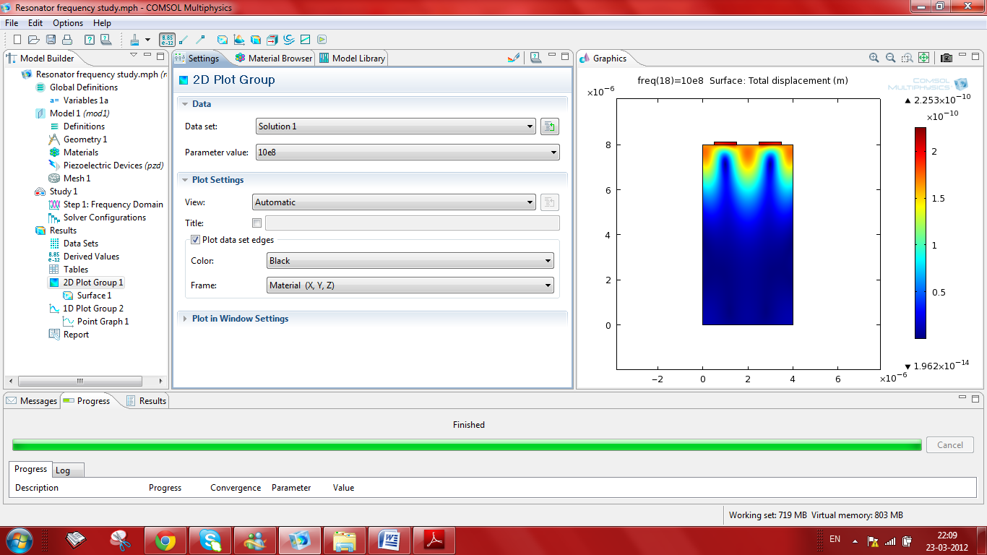

Plot between imag(pzd.nJ) versus frequency.
