Data representation in Excel (Peaks around 180 mV)
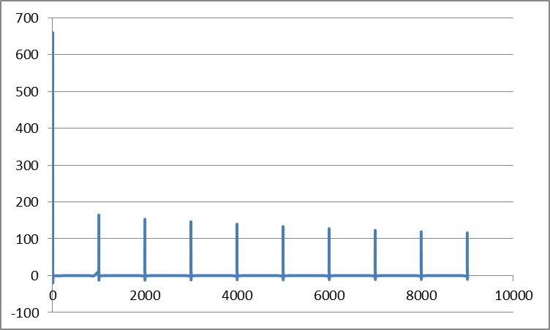

Data representation using interpolation function in COMSOL
