COMSOL, Inc.  100 District Avenue  Burlington, MA 01803 USA  Phone: +1 781-273-3322  Web: www.comsol.com  Blog: www.comsol.com/blogs/ | Media Contact:  Mia Johansson, PR & Communications Manager  Mia.johansson@comsol.com  COMSOL Certified Consultants:  www.comsol.com/certified-consultants

COMSOL Appoints the MTC as a COMSOL Certified Consultant

BURLINGTON, MA (August 8, 2019) — COMSOL is excited to announce that the Manufacturing Technology Centre (MTC) has officially joined the ranks of its global list of Certified Consultants.

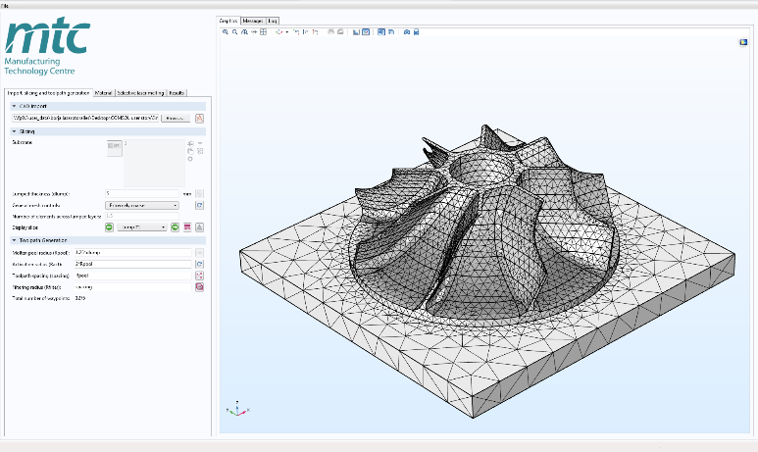
The MTC provides technologies and tools that advance the adoption of innovative manufacturing processes in the UK and beyond. The use of
The MTC delivers turnkey consultancy projects for the manufacturing industry, such as this additive manufacturing process simulator using COMSOL Multiphysics® software.

COMSOL Multiphysics® software allows them to create highly-accurate virtual models to predict the performance of and optimize processes for their clients. As a COMSOL Certified Consultant, MTC can expand into industries such as automotive, aerospace, food, electronics, and construction that need to incorporate multiphysics simulation in their R&D, manufacturing, and production to boost their competitiveness, reduce costs and time to market. They offer solutions for manufacturing systems, training, customized software applications, and more.

“With our in-depth knowledge and specialization of simulation processes for additive manufacturing, being appointed as a COMSOL Certified Consultant will allow us to reach a wider customer base, allowing us to have more impact through delivering high value simulation and specialised training materials,” said Borja Lazaro Toralles, MTC technology manager.

The MTC aims to provide a competitive environment to bridge the gap between university-based research and the development of innovative manufacturing solutions, in line with the UK Government’s manufacturing strategy. The MTC is part of the High Value Manufacturing Catapult, supported by Innovate UK.

Wen Zhang, managing director of COMSOL Ltd. (Cambridge, UK), said, " We have been working closely with the MTC team on diverse projects for a number of years and are excited to have them join the ranks of COMSOL Certified Consultants in the UK. With their expertise in manufacturing process development as well as physics modelling using the COMSOL Multiphysics® software, we are confident this recognition will further strengthen our collaborative efforts and allow the MTC to provide high quality simulation services across a wide range of industries."

Learn more about the MTC: www.comsol.com/certified-consultants/the-manufacturing-technology-centre

About COMSOL
COMSOL is a global provider of simulation software for product design and research to technical enterprises, research labs, and universities. Its COMSOL Multiphysics® product is an integrated software environment for creating physics-based models and simulation applications. A particular strength is its ability to account for coupled or multiphysics phenomena. Add-on products expand the simulation platform for electromagnetics, structural, acoustics, fluid flow, heat transfer, and chemical applications. Interfacing tools enable the integration of COMSOL Multiphysics® simulations with all major technical computing and CAD tools on the CAE market. Simulation experts rely on COMSOL Compiler™ and COMSOL Server™ to deploy applications to their design teams, manufacturing departments, test laboratories, and customers throughout the world. Founded in 1986, COMSOL has 19 offices worldwide and extends its reach with a network of distributors.
~
COMSOL Multiphysics is a registered trademark of COMSOL AB. For other trademark ownership, see www.comsol.com/trademarks.

About the MTC

The MTC (Manufacturing Technology Centre) was established to prove innovative manufacturing processes and technologies in an agile environment in partnership with industry, academia and other institutions. The MTC houses some of the most advanced manufacturing equipment in the world, creating a high quality environment for the development and demonstration of new technologies on an industrial scale. This provides a unique opportunity for manufacturers to develop new and innovative processes and technologies. www.the-mtc.org

