COMSOL Ltd.  Broers Building  21 JJ Thomson Avenue  Cambridge CB3 0FA  United Kingdom  Tel: +44 (0) 1223 451580  Fax: +44 (0) 1223 367361  Web: www.uk.comsol.com  E-mail: info.uk@comsol.com | Editor contact:  Kyle Mucha  Marketing  Kyle@comsol.com  Note to editors: Hi-res files for the following images are available for download at www.comsol.com/press/imagegallery.php

LMK Thermosafe Receive Queens Award for Business Success

Longstanding user of COMSOL Multiphysics and world leader in the design and manufacture of Induction Drum Heaters and Flexible Heating Jackets, LMK Thermosafe was presented with one of the most prestigious awards for UK business success in the category of International Trade

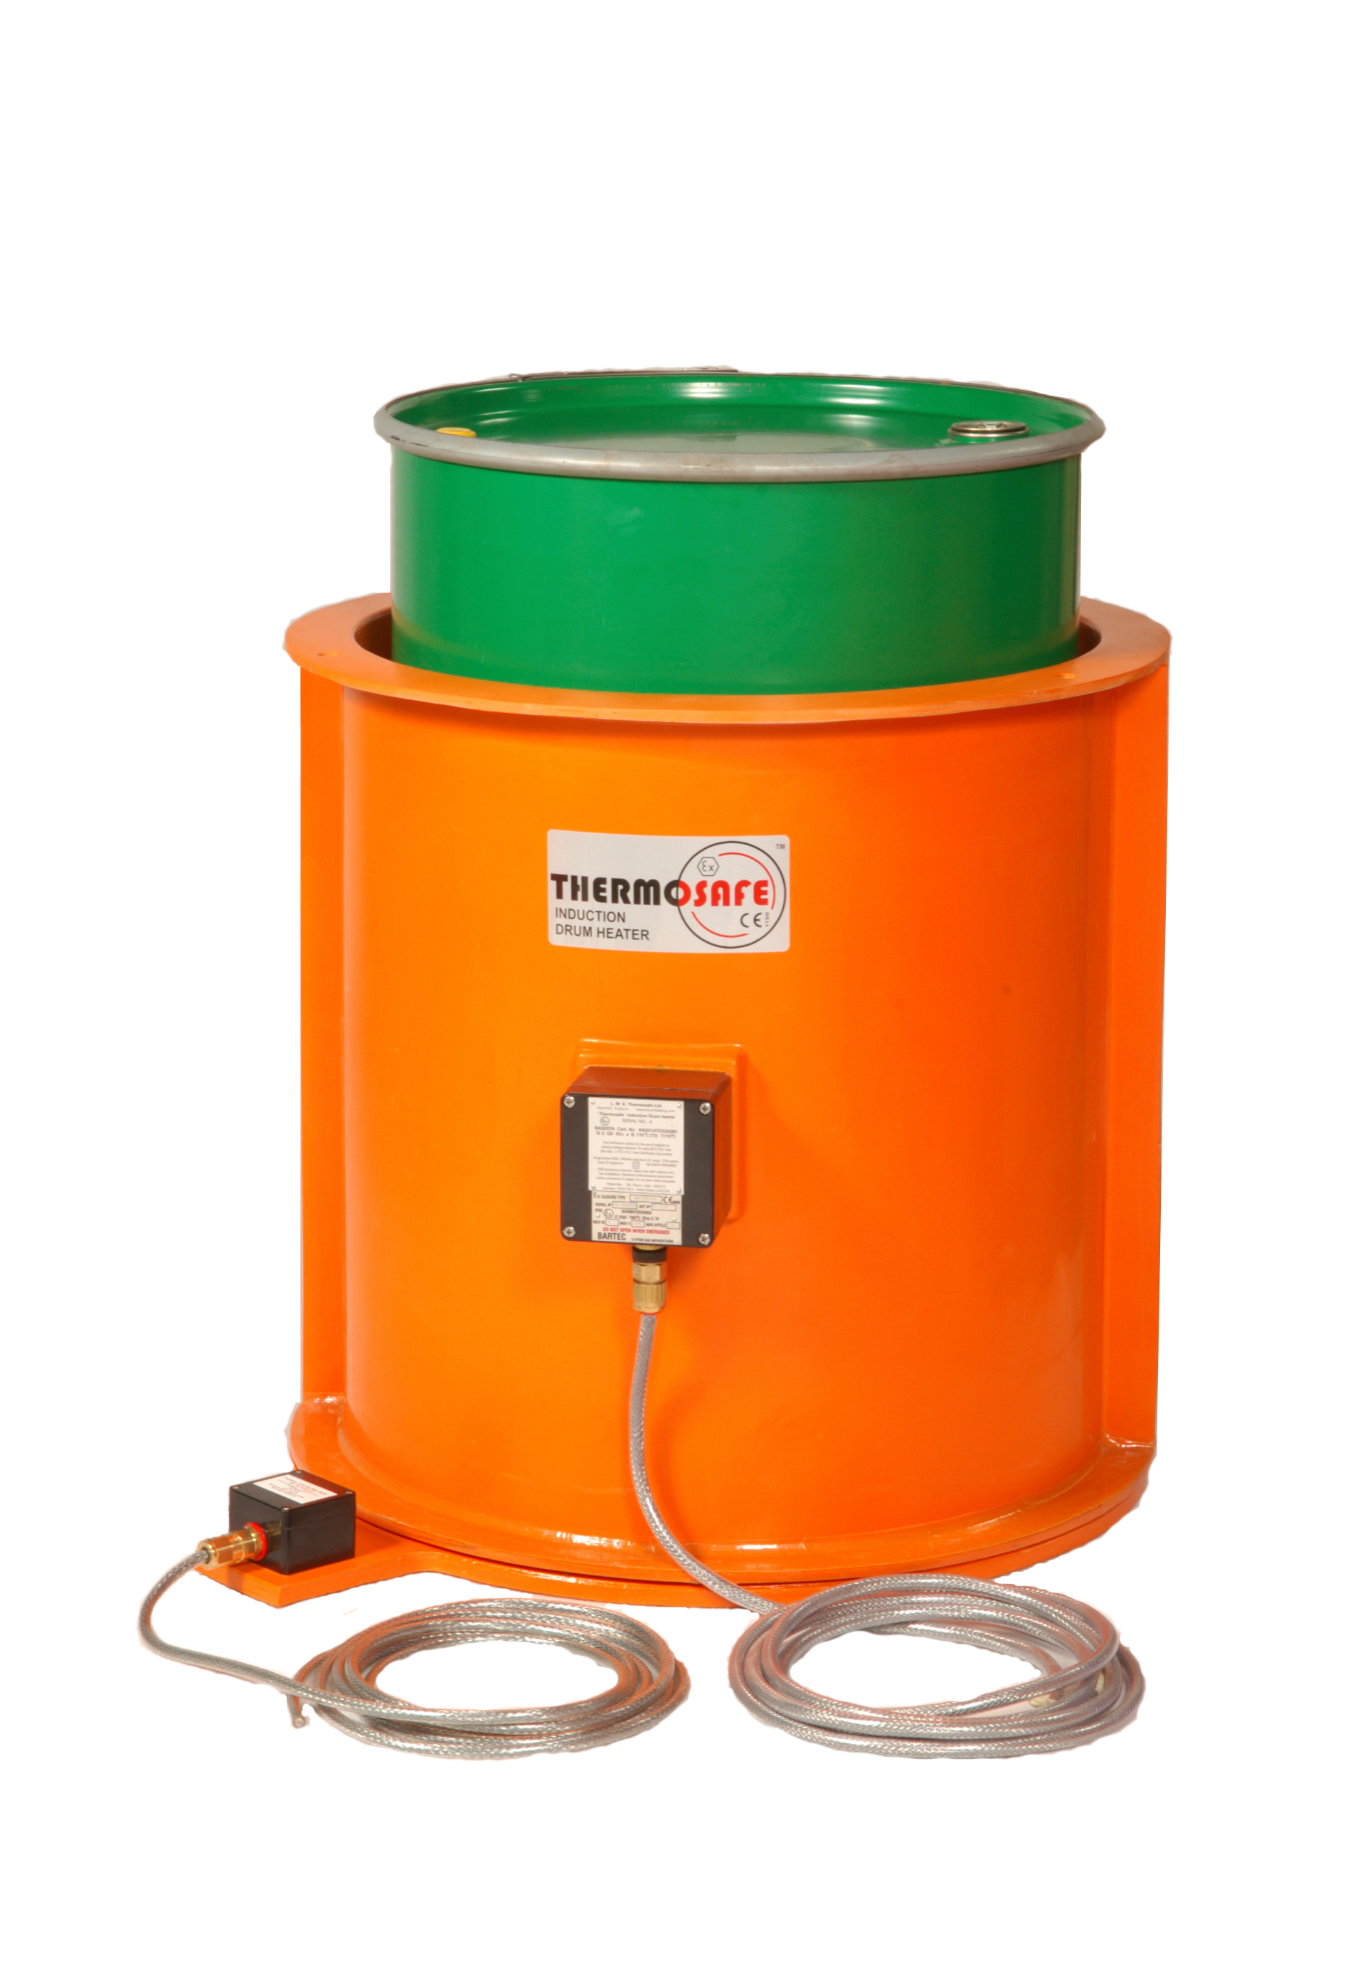
The Thermosafe Induction Drum Heater.
(Image courtesy of LMK Thermosafe)

Cambridge, UK (November 4th, 2012) — LMK Thermosafe, a longstanding user of COMSOL Multiphysics, was presented with one of the most prestigious awards for UK business success, The Queens Award for Enterprise in the category of International Trade. In recognition of the role that COMSOL Multiphysics has played in their product development process, COMSOL representatives were invited to join them on this auspicious occasion.

These highly prestigious awards are presented to UK businesses that show an outstanding achievement in the categories of Innovation, International Trade and Sustainable Development. They are made annually by HM The Queen, and are only given for the highest levels of excellence demonstrated in each category. In order to achieve such an honour LMK has had to demonstrate substantial growth in overseas earnings and commercial success.

Multiphysics driven product development leads to non-conventional heat transfer solutions
LMK Thermosafe initially purchased COMSOL Multiphysics to enable heat transfer and fluid flow modelling during an EU funded research project. Following on from this project, LMK Thermosafe has successfully used COMSOL Multiphysics to model and develop their current range of heating products. “The software has enabled the accurate modelling of problems involving induction and joule heating, non-isothermal flows (both laminar and turbulent) along with complex multiphase flows. This has enabled custom applications to be modelled and predicted, including the phase change of materials within different containers”, comments Jamie Evans, LMK’s Development Manager.

Looking at their product line it is clear how LMK Thermosafe has achieved this recognition of success. LMK are world leaders in the design and manufacture of the Induction Drum Heaters and Flexible Heating Jackets (see http://www.lmkengineering.co.uk/HJprods.htm), supplying more than 45 countries. The Thermosafe Induction Drum Heater is designed to heat 205 litre drums or smaller steel vessels, using a single induction coil, wholly encapsulated in a cylinder made from a glass reinforced resin. The energy is transferred by an alternating magnetic field, creating no need for heat transfer by the conventional and inefficient means of radiation or convection.

Dr Wen Zhang, VP of COMSOL’s UK office comments; “We are very pleased to see that LMK Thermosafe has grown their business so rapidly and are benefitting from the use of COMSOL Multiphysics. Working with companies such as LMK demonstrates how multiphysics simulation technology plays such an important role in the product development process. We wish LMK further success and look forward to continue to support their growing business”.

About LMK Thermosafe
More information about LMK’s product range can be found at http://drumheating.com.

About COMSOL

COMSOL Multiphysics is a software environment for the modeling and simulation of any physics-based system. A particular strength is its ability to account for multiphysics phenomena. Optional modules add discipline-specific tools for electrical, mechanical, fluid, and chemical applications. COMSOL Multiphysics and all its modules easily integrate with other parts of the CAD, CAE, and ECAD markets through built-in functionality or add-on products. Founded in 1986, the company has U.S. offices in Burlington, MA, Los Angeles, CA, and Palo Alto, CA. International operations have grown to include offices in the Benelux countries, Denmark, Finland, France, Germany, India, Italy, Norway, Sweden, Switzerland, and the United Kingdom. Independent distributors of COMSOL Multiphysics are located in Australia, China, the Czech Republic, Egypt, Greece, Hungary, Israel, Japan, Malaysia, Poland, South Africa, South Korea, Spain, Taiwan, and Turkey. Additional information about the company is available at www.comsol.com.

###

COMSOL, COMSOL Multiphysics, COMSOL Desktop, and LiveLink are registered trademarks or trademarks of COMSOL AB. Solid Edge is a registered trademark of Siemens Product Lifecycle Management Software Inc. Excel and Windows are registered trademarks of Microsoft Corporation. Amazon EC2 and Amazon Elastic Compute Cloud are trademarks of Amazon Web Services, LLC or its affiliates. Other product or brand names are trademarks or registered trademarks of their respective holders.
Thermosafe is a registered trademark of LMK Thermosafe Ltd.

