COMSOL, Inc.  1 New England Executive Park  Burlington, MA 01803 USA  Phone: +1 781-273-3322  Web: www.comsol.com  E-mail: info@comsol.com | Editor contact:  Valerio Marra  Technical Marketing Manager  valerio@comsol.com  You can explore the mechanical showcase at www.comsol.com/showcase/mechanical
New Online Resource: Analyzing Mechanical Systems & Designs

BURLINGTON, MA (June 17, 2014) – A new online resource for mechanical engineers is now available on the COMSOL website. The Analyzing Mechanical Systems & Designs showcase is a comprehensive online resource featuring content about applications, physics, and industries pertaining to the modeling of mechanical designs. Using the resource, engineers from all disciplines can gain insight into applications that include mechanical effects and that require multiphysics simulation for their successful design. Explore information about modeling thermal stress and deformation, acoustics, multibody dynamics, nonlinear materials, and much more at: www.comsol.com/showcase/mechanical.

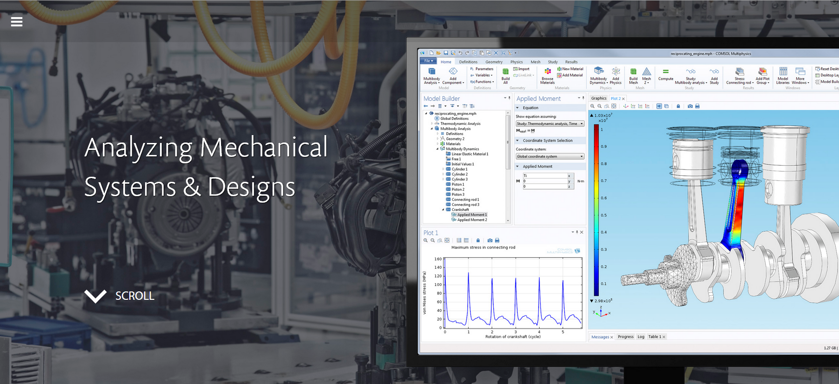

Modeling Mechanical Systems with Real-World Accuracy
The COMSOL Multiphysics software allows for a unified simulation that couples physics phenomena in a way that accurately replicates their interactions in the real world. The mechanical showcase was created as a resource to demonstrate the powerful modeling capabilities of COMSOL Multiphysics for simulating the physics involved in mechanical systems, depicting how mechanical phenomena can be accurately captured and analyzed. It contains rich content including videos, case studies, presentations, and example models that illustrate how a physical prototype or design idea can most accurately be represented using finite element analysis. First-hand accounts from world-renowned companies detail how multiphysics modeling has helped improve device design, shortened time to market, and allowed for innovative concepts to be quickly explored.

About COMSOL
COMSOL provides simulation software for product design and research to technical enterprises, research labs, and universities through 20 offices and a distributor network throughout the world. Its flagship product, COMSOL Multiphysics®, is a software environment for modeling and simulating any physics-based system. A particular strength is its ability to account for coupled or multiphysics phenomena. Add-on products expand the simulation platform for electrical, mechanical, fluid flow, and chemical applications. Interfacing tools enable the integration of COMSOL Multiphysics® simulation with all major technical computing and CAD tools on the CAE market.
~
COMSOL, COMSOL Multiphysics, Capture the Concept, COMSOL Desktop, and LiveLink are either registered trademarks or trademarks of COMSOL AB. All other trademarks are the property of their respective owners, and COMSOL AB and its subsidiaries and products are not affiliated with, endorsed by, sponsored by, or supported by those trademark owners. For a list of such trademark owners, see www.comsol.com/trademarks.

