COMSOL, Inc.  1 New England Executive Park  Burlington, MA 01803 USA  Phone: +1 781-273-3322  Web: www.comsol.com  E-mail: info@comsol.com | Editor contact:  Valerio Marra  Technical Marketing Manager  valerio@comsol.com  Download the magazine at: www.comsol.com/offers/comsolnews14
COMSOL News 2014 Features Innovative Simulation Research

BURLINGTON, MA (July 21, 2014) – COMSOL, Inc. is excited to announce that the latest edition of COMSOL News is now available and can be downloaded at www.comsol.com/offers/comsolnews14. Within the magazine, you’ll find insight into how multiphysics simulation is positively influencing all aspects of the design process – from the conceptual phase of product development until a product is delivered to the market, and even after, as new discoveries lead to continuous design improvements.

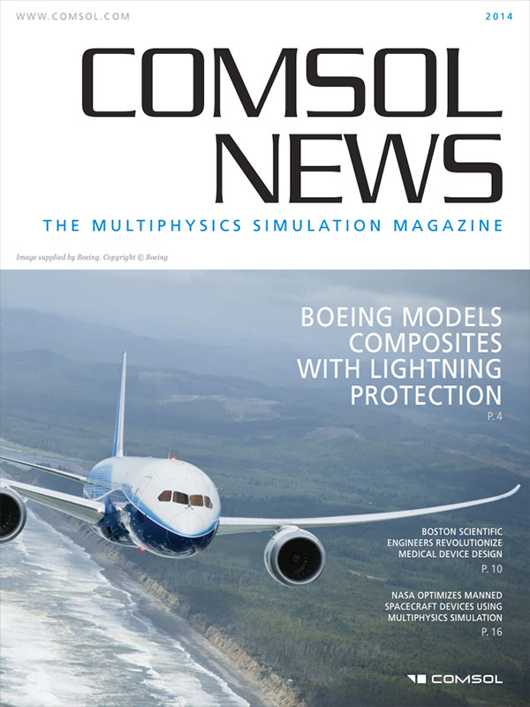
For example, you’ll learn how Boeing engineers used COMSOL Multiphysics to investigate and verify thermal expansion in the aircraft composite materials that makes up over 50 percent of the Boeing 787’s outer shell. Another article explores how Boston Scientific researchers used simulation to gain knowledge about the release mechanism of drug-eluting stents. Additionally, simulation was a vital aspect of the design process at NASA, where aerospace engineers are working on the development of life support systems that provide breathable air and drinkable water for astronauts.

The companies featured in the magazine faced varying design challenges, but all found solutions by employing simulation. This common theme attests to the adaptability of the COMSOL software, proving that multiphysics simulation, when used throughout the design process, allows engineers to accurately model designs that comprise all relevant physics effects. This approach to product design is helping companies to increase productivity, cut development time, and stay current with market trends.
Turn to page 4 to see how simulation was used when designing the Boeing 787 line of aircraft.

Mentioned here are just a few highlights of the innovative work achieved by engineers relying on the power and accuracy of the multiphysics approach to simulation. From building physics to tire pressure sensors and lab-on-a-chip devices, there are many exciting projects featured from a variety of application areas. View the magazine now at: www.comsol.com/offers/comsolnews14

About COMSOL
COMSOL provides simulation software for product design and research to technical enterprises, research labs, and universities through 20 offices and a distributor network throughout the world. Its flagship product, COMSOL Multiphysics®, is a software environment for modeling and simulating any physics-based system. A particular strength is its ability to account for coupled or multiphysics phenomena. Add-on products expand the simulation platform for electrical, mechanical, fluid flow, and chemical applications. Interfacing tools enable the integration of COMSOL Multiphysics® simulation with all major technical computing and CAD tools on the CAE market.
~
COMSOL, COMSOL Multiphysics, Capture the Concept, COMSOL Desktop, and LiveLink are either registered trademarks or trademarks of COMSOL AB. All other trademarks are the property of their respective owners, and COMSOL AB and its subsidiaries and products are not affiliated with, endorsed by, sponsored by, or supported by those trademark owners. For a list of such trademark owners, see www.comsol.com/trademarks.

