COMSOL, Inc.  1 New England Executive Park  Burlington, MA 01803 USA  Phone: +1 781-273-3322  Web: www.comsol.com  Media Contact:  Natalia Switala, PR & Communications Project Manager  natalia@comsol.com | COMSOL LLC  Bolshaya Sadovaya 10  125047 Moscow, Russia  Phone: +7 963 720-30-80  Web: www.comsol.ru  Media Contact:  Evgeny Kuznetsov, Managing Director  Evgeny@comsol.com

COMSOL Opens New office in Moscow, Russia

BURLINGTON, MA (March 30, 2015) – COMSOL, the leading provider of multiphysics simulation and analysis software, today announced the opening of a new office in Moscow, Russia. The new office provides sales and support for the growing community of COMSOL Multiphysics® users in Russia. Services include local sales, technical support, training sessions, and on-site workshops, seminars, and customer visits.

"Russia is known for its strong school of physics and mathematics,” says Evgeny Kuznetsov, Managing Director of COMSOL LLC. “This has helped the country to obtain leading positions in knowledge-intensive industries, including rocket engine design and nuclear power stations. Oil and gas is another example of a sophisticated industry in Russia where multiphysics modeling can significantly improve efficiency and help develop new technologies—from exploration to distribution and beyond.”
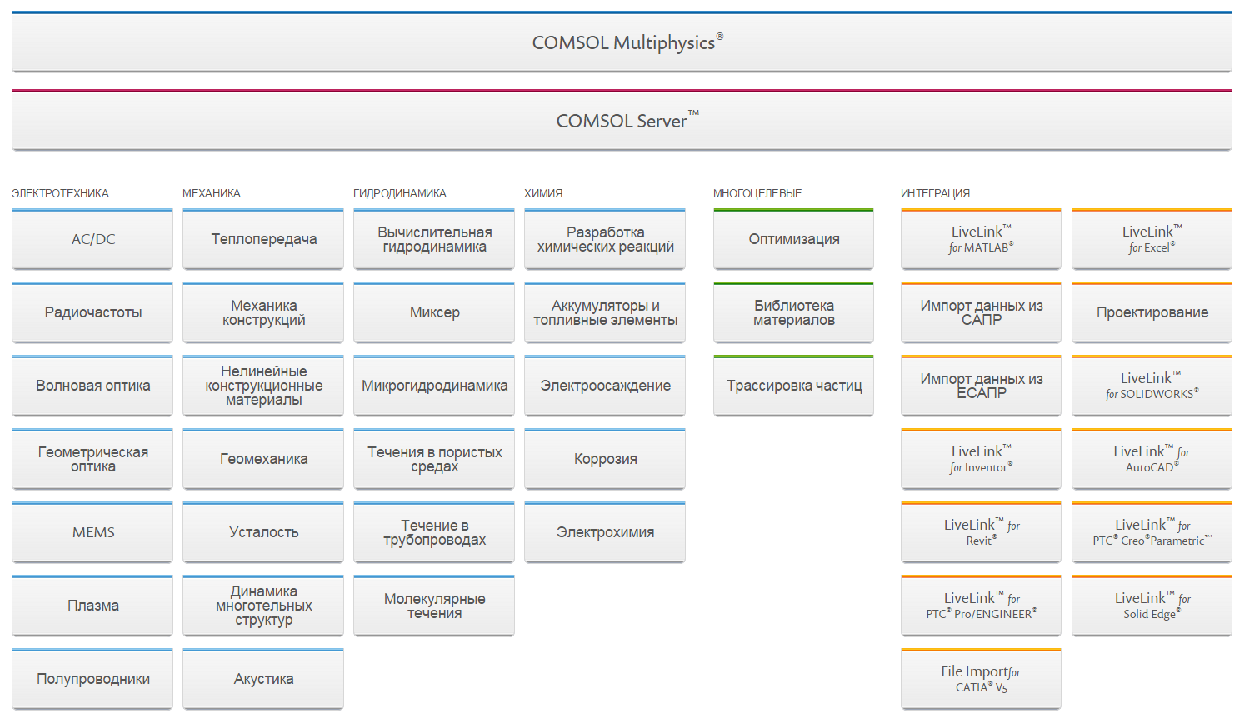
The COMSOL software product suite shown at www.comsol.ru, which includes products for simulating any application in the electrical, mechanical, fluid, and chemical disciplines.

Egor Vtorushin, researcher at the Novosibirsk Technology Center of Baker Hughes, expresses his excitement about the new office: "We use COMSOL Multiphysics software and the AC/DC Module for the numerical simulation of electromagnetic logging. We welcome the opening of the COMSOL office in Russia and look forward to interacting more closely with their technical support and sales teams.”

The opening of the Russian office comes at an auspicious time for COMSOL, as the Application Builder and COMSOL Server™ were recently released with COMSOL Multiphysics version 5.0. “We are investing in our rapidly growing user base,” says Farhad Saeidi, President of COMSOL AB. “The Application Builder will make simulation applications available to a wider audience, while the high-tech community in Moscow will be key for establishing a dedicated COMSOL user base in Russia. Our customers in Russia and their entire organizations will be able to benefit from both the local office and the software’s new tools right away.”

Upcoming events in Russia include seminars in Moscow, St. Petersburg, Novosibirsk, and Kazakhstan.

“Moscow is the heart of Russia,” concludes Kuznetsov. “The new COMSOL office will bring the company’s innovative, vibrant, and cutting-edge corporate culture closer to local users. This will improve the quality of services, making COMSOL Multiphysics even more valuable for engineers, researchers, and developers."

About COMSOL
COMSOL provides simulation software for product design and research to technical enterprises, research labs, and universities through 22 offices and a distributor network throughout the world. Its flagship products, COMSOL Multiphysics® and COMSOL Server™, are software environments for modeling and simulating any physics-based system and for building and distributing applications. A particular strength is its ability to account for coupled or multiphysics phenomena. Add-on products expand the simulation platform for electrical, mechanical, fluid flow, and chemical applications. Interfacing tools enable the integration of COMSOL Multiphysics simulation with all major technical computing and CAD tools on the CAE market.
~
COMSOL, COMSOL Server, and COMSOL Multiphysics are either registered trademarks or trademarks of COMSOL AB.

