COMSOL, Inc.  1 New England Executive Park  Burlington, MA 01803 USA  Phone: +1 781-273-3322  Web: www.comsol.com  Blog: www.comsol.com/blogs | Media Contact:  Natalia Switala, PR & Communications Project Manager  natalia@comsol.com  Download COMSOL News 2015 at:  www.comsol.com/offers/comsolnews15

COMSOL News 2015 Features State-of-the-Art Work Using
Multiphysics Simulation and Delivers First In-Depth Look
at the Introduction of Simulation Apps

BURLINGTON, MA (June 30, 2015) — COMSOL, the leading provider of multiphysics modeling and simulation software, has announced the latest edition of COMSOL News, the company’s annual multiphysics simulation journal. The 2015 edition features articles on the state-of-the-art in multiphysics simulation for a wide range of industries, from food processing to corrosion protection to laser-matter interaction. The latest issue also provides an inside look at the introduction of simulation applications. Industry leaders discuss how their simulation experts are creating ready-to-use apps for sharing designs across multiple departments, such as in calculating the deformation of manufactured parts using shaped metal deposition in 3D printing.
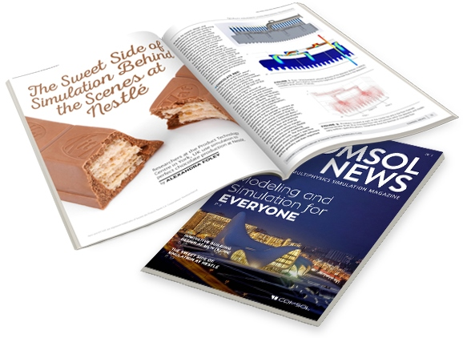
COMSOL News articles are drawn from the innovative work being done by subject matter experts who are users of COMSOL Multiphysics® simulation software. Over a dozen feature articles in this year’s 40-page edition cover such topics as optimizing photovoltaic materials, making biofuels, investigating elevator accidents, heating and cooling buildings, and designing audio components.

Guest commentary is provided by Jim Knox, NASA's roadmap function manager for the maturation of CO₂ removal systems. His column, “Simulation Apps Bring Us Closer to Mars,” talks about NASA’s use of simulation to capture intricate processes.

“Multiphysics simulation and related tools used for creating specialized simulation apps are being put to great use for just about everything from R&D to manufacturing,” said Valerio Marra, Technical Marketing Manager at COMSOL. “Many breakthrough technological innovations and products have recently seen the light of day. Our goal is help foster design innovations by delivering the right tools for the job. This issue of COMSOL News provides insights into best practices, such as the simulation work that optimizes the production process at Nestle and the development of 3D printing simulation apps at MTC. Above all, our sincerest thanks to the many COMSOL® software users who contributed their time and talent to this journal.”

Availability
COMSOL News 2015 is available as an online magazine and can be downloaded in PDF format at www.comsol.com/offers/comsolnews15

About COMSOL
COMSOL provides simulation software for product design and research to technical enterprises, research labs, and universities through 22 offices and a distributor network throughout the world. Its flagship product, COMSOL Multiphysics®, is a software environment for modeling and simulating any physics-based system and for building applications. A particular strength is its ability to account for coupled or multiphysics phenomena. Add-on products expand the simulation platform for electrical, mechanical, fluid flow, and chemical applications. Interfacing tools enable the integration of COMSOL Multiphysics® simulation with all major technical computing and CAD tools on the CAE market.
~
COMSOL and COMSOL Multiphysics are registered trademarks of COMSOL AB.

