COMSOL, Inc.  100 District Avenue  Burlington, MA 01803 USA  Phone: +1 781-273-3322  Web: www.comsol.com  Blog: www.comsol.com/blogs | Media Contact:  Natalia Switala, PR & Communications Project Manager  natalia@comsol.com  COMSOL News 2016 is available at:  www.comsol.com/offers/comsol-news-2016

COMSOL News 2016 Explains How
Simulation Specialists Are Bringing Multiphysics to Everyone

BURLINGTON, MA (May 9, 2016) — COMSOL, Inc. has published the latest edition of COMSOL News, the company’s annual multiphysics journal reporting on its customers innovative applications. The 2016 edition focuses on simulation specialists bringing multiphysics to everyone so companies can easily develop, clearly communicate and readily distribute designs across teams and client bases.

COMSOL News 2016 reports on how custom applications built using the COMSOL Multiphysics® software allow cross-team collaboration; and how the COMSOL Server™ product enables the distribution of these applications for colleagues and customers to use. Industry experts explain how they harness COMSOL® software to create detailed physics-based models and deliver on innovative product development and research projects; from designers and engineers at NASA investigating combustion instability in rocket engines, to a research group at the University at Buffalo designing simulation apps for use across a wide variety of industries such as, 3D printing and traffic control.

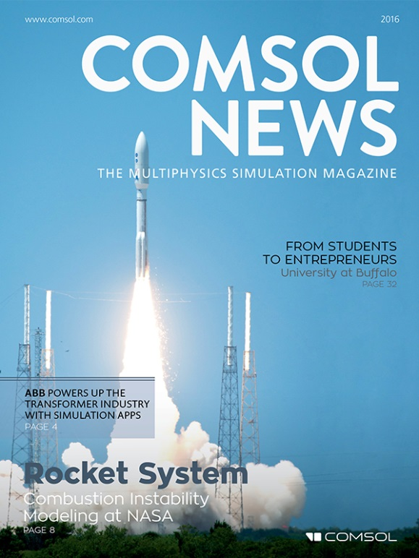
The latest COMSOL News issue features more than a dozen articles in this year’s 40-page edition, which cover a diverse range of projects. These include pieces on ABB engineers using the COMSOL Multiphysics® software to predict and minimize the noise levels in their transformers; students and consultants collaborating to save historic structures and artifacts with the use of simulation apps; and simulation specialists creating virtual testing apps for furniture manufacturers.

Guest editorial is provided by Dr. Carl Meinhart, a professor of Mechanical Engineering at the University of California, Santa Barbara and founder and CEO of Numerical Design, Inc. Dr. Meinhart gives insight into how the COMSOL Multiphysics® software is used in both academia and industry to solve complex multidisciplinary problems. “The reason is simple: What would previously require a custom numerical algorithm, from advanced multiphysics applications to optimization analysis, can be easily solved by COMSOL® software,” he said. “With COMSOL®, we are able to quickly simulate and analyze many design concepts, and optimize the designs, before committing to actual hardware fabrication.”

COMSOL News 2016 highlights the innovative work done by COMSOL® software users including a computational app for testing new oil spill cleanup techniques using hydrophobic meshes and research into man made stars at the MIT Plasma Science and Fusion Center using numerical simulations to evaluate and optimize the proposed design of a compact nuclear fusion machine.

Availability
COMSOL News 2016 is available as an online magazine and can be viewed digitally or downloaded in PDF format at: https://www.comsol.com/offers/comsol-news-2016.

About COMSOL
COMSOL is a global provider of simulation software for product design and research to technical enterprises, research labs, and universities. Its COMSOL Multiphysics® product is an integrated software environment for creating physics-based models and simulation apps. A particular strength is its ability to account for coupled or multiphysics phenomena. Add-on products expand the simulation platform for electrical, mechanical, fluid flow, and chemical applications. Interfacing tools enable the integration of COMSOL Multiphysics® simulations with all major technical computing and CAD tools on the CAE market. Simulation experts rely on the COMSOL Server™ product to deploy apps to their design teams, manufacturing departments, test laboratories, and customers throughout the world. Founded in 1986, COMSOL employs more than 400 people in 22 offices worldwide and extends its reach with a network of distributors.
~
COMSOL, COMSOL Multiphysics, Capture the Concept, and COMSOL Desktop are registered trademarks of COMSOL AB. COMSOL Server, LiveLink, and Simulation for Everyone are trademarks of COMSOL AB. Other product or brand names are trademarks or registered trademarks of their respective holders.

