COMSOL, Inc.  100 District Avenue  Burlington, MA 01803 USA  Phone: +1 781-273-3322  Web: www.comsol.com  Blog: www.comsol.com/blogs | Media Contact:  Natalia Switala, PR & Communications Project Manager  natalia@comsol.com  Attend a COMSOL Days event near you:  www.comsol.com/comsol-days

CAE Democratization in Focus at COMSOL Days 2017

COMSOL Days will be hosted in major cities around the globe to support the creation and large-scale deployment of custom simulation apps by offering training opportunities, talks by invited speakers, and the opportunity to exchange ideas with pioneer app designers in the COMSOL community.

BURLINGTON, MA (January 12, 2017) — COMSOL, Inc. the leading provider of software solutions for multiphysics modeling and simulation, today announced the COMSOL Days schedule for 2017. The COMSOL Day events are open to anyone who wants to advance their multiphysics modeling skills and learn how to build custom simulation apps. The day will consist of training, talks by invited speakers, and the opportunity to connect with the COMSOL community.

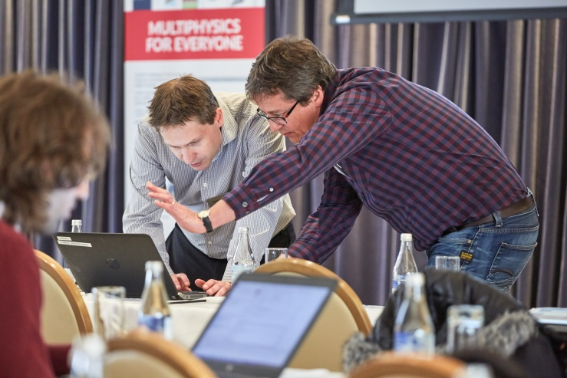
“Our mission is to expand access to numerical simulation to engineers without previous experience using multiphysics software. To achieve this goal, we released the Application Builder tool for COMSOL Multiphysics for creating custom apps and COMSOL Server license for deployment and access through a web browser or a client,” comments Jeff Hiller, VP of Sales, COMSOL, Inc. “COMSOL Days directly support that mission by bringing new and existing users together for a daylong event consisting of training, invited talks, and countless opportunities to exchange ideas with peers and application specialists from COMSOL.”
COMSOL users connecting with the COMSOL community.

There are COMSOL Days scheduled around the globe in major cities such as Bethesda, MD; Cambridge, MA; Detroit, MI; Toronto, ON; Paris, France; Brescia, Italy. For the full list of cities and for more details about COMSOL Days and to register and attend, visit: www.comsol.com/comsol-days.

About COMSOL
COMSOL is a global provider of simulation software for product design and research to technical enterprises, research labs, and universities. Its COMSOL Multiphysics® product is an integrated software environment for creating physics-based models and simulation apps. A particular strength is its ability to account for coupled or multiphysics phenomena. Add-on products expand the simulation platform for electrical, mechanical, fluid flow, and chemical applications. Interfacing tools enable the integration of COMSOL Multiphysics® simulations with all major technical computing and CAD tools on the CAE market. Simulation experts rely on the COMSOL Server™ product to deploy apps to their design teams, manufacturing departments, test laboratories, and customers throughout the world. Founded in 1986, COMSOL employs more than 480 people in 21 offices worldwide and extends its reach with a network of distributors.
~
COMSOL, COMSOL Multiphysics, Capture the Concept, and COMSOL Desktop are registered trademarks of COMSOL AB. COMSOL Server, LiveLink, and Simulation for Everyone are trademarks of COMSOL AB. Other product or brand names are trademarks or registered trademarks of their respective holders.

