COMSOL, Inc.  100 District Avenue  Burlington, MA 01803 USA  Phone: +1 781-273-3322  Web: www.comsol.com  Blog: www.comsol.com/blogs | Media Contact:  Natalia Switala, PR & Communications Project Manager  natalia@comsol.com  COMSOL® software update details:  www.comsol.com/product-update

LiveLink™ for SOLIDWORKS® from COMSOL Allows Users to
Build Simulation Apps that Integrate with CAD

Users of SOLIDWORKS® software can now fully benefit
from the power of multiphysics analysis through simulation apps.

BURLINGTON, MA (February 1, 2017) — COMSOL, Inc. the leading provider of software solutions for multiphysics modeling, simulation, app design and deployment, has announced an update to its LiveLink™ for SOLIDWORKS® product. As an add-on to the COMSOL Multiphysics® software, LiveLink™ for SOLIDWORKS® allows a CAD model to be synchronized between the two software packages.

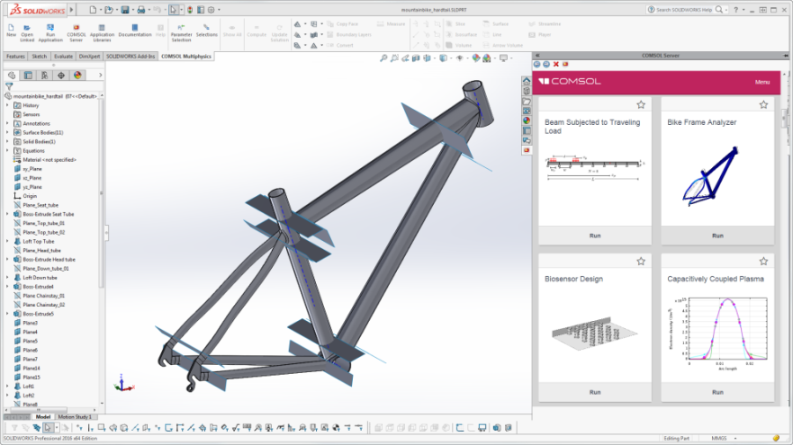
Connecting to COMSOL Server™ from within the SOLIDWORKS® Interface
The COMSOL Multiphysics® ribbon tab and embedded COMSOL Server™ interface in the SOLIDWORKS® user interface.
The latest version of LiveLink™ for SOLIDWORKS® allows easy access for launching and running simulation apps that can be used in synchronicity with SOLIDWORKS® software. Simulation specialists and analysts can now build apps with the Application Builder to let users, such as design engineers, to analyze and modify a geometry from SOLIDWORKS® software right from the tailor made interface of the app. Users can browse and run apps from within the SOLIDWORKS® interface, including those that use a geometry that is synchronized with SOLIDWORKS® software.

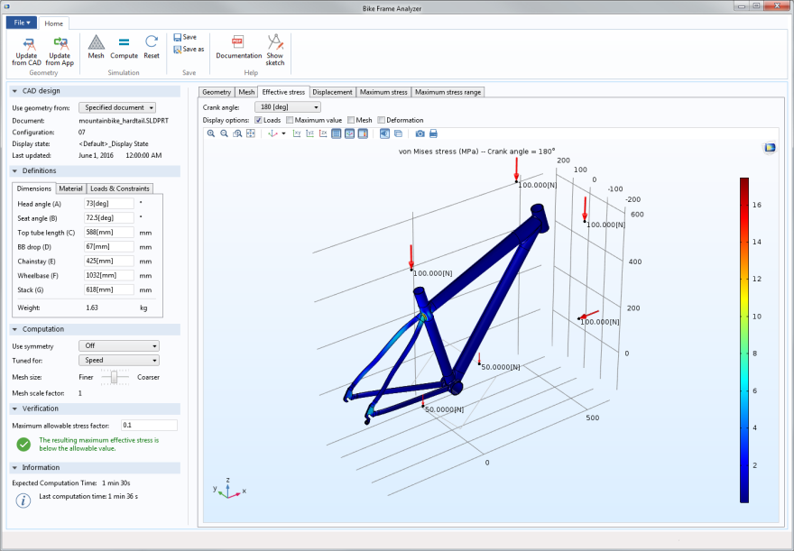
New App: Bike Frame Analyzer
The user interface of the Bike Frame Analyzer app showing the effective stress on the frame with a 180-degree crank angle.
With this update of LiveLink™ for SOLIDWORKS® a new Bike Frame Analyzer app has been added to the Application Libraries in order to show the new capabilities. This app leverages LiveLink™ for SOLIDWORKS® to interactively update the geometry while computing the stress distribution in the frame that is subject to various loads and constraints. Using this app, you can easily test different configurations of a bike frame for different parameters such as, dimensions, materials, and loads. The app computes the stress distribution and the deformation of the frame, based on the structural dimensions, materials, and loads/constraints of the bike frame.
Availability
To download the latest version of COMSOL Multiphysics® software and COMSOL Server™ product or update your current installation, visit www.comsol.com/product-update.

About COMSOL
COMSOL is a global provider of simulation software for product design and research to technical enterprises, research labs, and universities. Its COMSOL Multiphysics® product is an integrated software environment for creating physics-based models and simulation apps. A particular strength is its ability to account for coupled or multiphysics phenomena. Add-on products expand the simulation platform for electrical, mechanical, fluid flow, and chemical applications. Interfacing tools enable the integration of COMSOL Multiphysics® simulations with all major technical computing and CAD tools on the CAE market. Simulation experts rely on the COMSOL Server™ product to deploy apps to their design teams, manufacturing departments, test laboratories, and customers throughout the world. Founded in 1986, COMSOL employs more than 480 people in 21 offices worldwide and extends its reach with a network of distributors.
~
COMSOL, COMSOL Multiphysics, Capture the Concept, and COMSOL Desktop are registered trademarks of COMSOL AB. COMSOL Server, LiveLink, and Simulation for Everyone are trademarks of COMSOL AB. SOLIDWORKS is a registered trademark of Dassault Systèmes or its subsidiaries in the United States and/or other countries. Other product or brand names are trademarks or registered trademarks of their respective holders.

