COMSOL BV  Röntgenlaan 37  2719 DX Zoetermeer  Tel: 079 3634230  Web: www.comsol.nl  Blog: www.comsol.nl/blogs | Media Contact:  Saskia de Witt – de Bruijn  saskia.dewitt@comsol.com  COMSOL® software products:  http://www.comsol.nl/products

Svante Littmarck President and CEO of COMSOL to Give Plenary Lecture at 2nd Thermal and Fluids Engineering Conference (TFEC)

Participants at the conference will learn how multiphysics simulation is more powerful and much less complicated than ever with the adoption of custom simulation applications.

ZOETERMEER, THE NETHERLANDS (March 28, 2017) — COMSOL, Inc. the leading provider of software solutions for multiphysics modeling, simulation, app design and deployment, will be featured at the 2nd Thermal and Fluids Engineering Conference (TFEC). With a focus on “Engineering Challenges for the Betterment of Society”, this year’s conference will provide an international forum for discussing the latest research and development achievements in the thermal and fluid sciences and the impact on numerical simulation. Svante Littmarck, President and CEO of COMSOL, Inc., will give a plenary lecture on the latest achievements of multiphysics simulation. COMSOL will also offer the attendees a course on “Multiphysics Simulation of Thermal and Fluid Systems.”

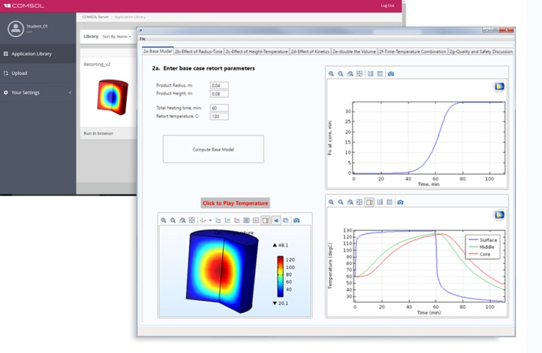
Custom simulation apps bring new opportunities
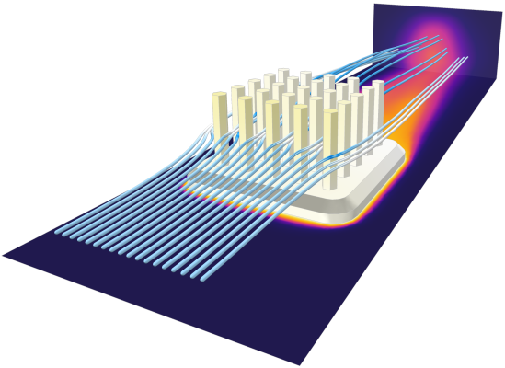
“Thanks to custom simulation apps, powerful computational tools are able to reach a wider group of users than ever before,” says Svante Littmarck. “During the lecture I will discuss use cases and show how state-of-the-art multiphysics software can be used to benefit simulation specialists, their colleagues, and customers alike.” The adoption of apps is spreading quickly across industry and academia supported by the ease of use of the Application Builder in the COMSOL Multiphysics® software and cost-effective deployment through a local installation of the COMSOL Server™ product. Cornell University is an example where large scale deployment of apps through COMSOL Server™ benefits students and teachers nationwide without them having to directly invest in the software or hardware. “Simulation apps bring new opportunities to education,” says Prof. Ashim Datta, Department of Biological & Environmental Engineering, Cornell University. “In a food safety class, apps enable multidisciplinary learning where students of biological science can simulate many what-if scenarios realistically.” Littmarck concludes, “Engineers can benefit from powerful mathematical modeling tools and solver technology in COMSOL Multiphysics® and deliver custom apps with COMSOL Server™. Deploying apps to their organization and customers worldwide has never been more straightforward.”
A local installation of COMSOL Server™ at Cornell University for the deployment of apps to students in a food safety class.

Multiphysics Simulation of Thermal and Fluid Systems
COMSOL will offer a course on “Multiphysics Simulation of Thermal and Fluid Systems”. David Kan, vice president of sales for the southwestern region of the US, and Nicolas Huc, Technical Product Manager, Heat Transfer, will introduce the participants to multiphysics simulation using the COMSOL® software. The course will focus on the design of a heat sink to demonstrate how to model conjugate heat transfer step-by-step. Engineers and scientists are turning to the accuracy of multiphysics modeling software to optimize their designs and for deeper understanding of processes involving fluid flow and heat transfer. The ability to model conjugate heat transfer, alongside other physics, with high-fidelity is of the essence as it’s the main physics phenomena driving ubiquitous processes and components such as heat exchangers, thermoelectric coolers, bioheating devices, laser heating, thermal lensing, electronic cooling, induction heating, and RF heating.
Conjugate heat transfer simulation of a heat sink performed with the COMSOL Multiphysics® software.

About the Thermal and Fluids Engineers Conference
The 2017 American Society of Thermal and Fluids Engineers (ASTFE) Conference and 4th International Workshop on Heat Transfer (IWHT) will be co-located and held April 2-5, 2017 in the Rio Hotel & Casino in Las Vegas, NV. The conference (www.astfe.org/tfec2017) and workshop provide an international forum for the presentation of the latest research and knowledge as well as for dissemination of high-quality research and development results in the thermal and fluid sciences.

About COMSOL
COMSOL is a global provider of simulation software for product design and research to technical enterprises, research labs, and universities. Its COMSOL Multiphysics® product is an integrated software environment for creating physics-based models and simulation apps. A particular strength is its ability to account for coupled or multiphysics phenomena. Add-on products expand the simulation platform for electrical, mechanical, fluid flow, and chemical applications. Interfacing tools enable the integration of COMSOL Multiphysics® simulations with all major technical computing and CAD tools on the CAE market. Simulation experts rely on the COMSOL Server™ product to deploy apps to their design teams, manufacturing departments, test laboratories, and customers throughout the world. Founded in 1986, COMSOL employs more than 480 people in 21 offices worldwide and extends its reach with a network of distributors.
~
COMSOL, COMSOL Multiphysics, Capture the Concept, and COMSOL Desktop are registered trademarks of COMSOL AB. COMSOL Server, LiveLink, and Simulation for Everyone are trademarks of COMSOL AB. SOLIDWORKS is a registered trademark of Dassault Systèmes or its subsidiaries in the United States and/or other countries. Other product or brand names are trademarks or registered trademarks of their respective holders.

