COMSOL, Inc.  100 District Avenue  Burlington, MA 01803 USA  Phone: +1 781-273-3322  Web: www.comsol.com  Blog: www.comsol.com/blogs | Media Contact:  Natalia Switala, PR & Communications Manager  natalia@comsol.com  COMSOL Conference 2017 Papers and Posters:  www.comsol.com/2017-user-presentations

500 Papers and Posters on Multiphysics Simulation
Now Available for Public Access

Papers and posters from multiphysics simulation specialists have been published online in addition to the announcement of the award winners from the COMSOL Conference.

BURLINGTON, MA (January 30, 2018) — The 2017 COMSOL Conference, held in seven locations across the globe, brought together thousands of engineers, researchers, and designers worldwide. Attendees connected and exchanged best practices in mathematical modeling and multiphysics simulation. Keynote presentations were delivered by industry leaders such as Amgen, W. L. Gore and Associates, and STMicroelectronics. Attendees also got a behind the scenes look at how these organizations develop their designs. Many talks shared how to capitalize on the power of multiphysics modeling by expanding its reach through custom simulation apps.

Users of the COMSOL Multiphysics® software presented posters and papers sharing their work and insights of numerical simulation. Areas covered include structural mechanics, CFD, heat transfer, electromagnetics, acoustics, and chemical engineering. Engineers from MIT, Oak Ridge National Laboratory, and Beth Israel Deaconess Medical Center, among others showed how they are using multiphysics simulation to advance their work. To learn from others, browse through the hundreds of papers and posters that are now publicly available online at www.comsol.com/2017-user-presentations.

Best Paper and Best Poster Awards
The 2017 COMSOL Conference kicked off in Boston before heading to Rotterdam, Beijing, Singapore, Taipei, Seoul, and Tokyo. Each location had a program committee of simulation specialists from industry and academia review the submissions and select the winners. The winners recognized with Best Paper and Best Poster awards can be found at www.comsol.com/2017-user-presentations/award-winners.

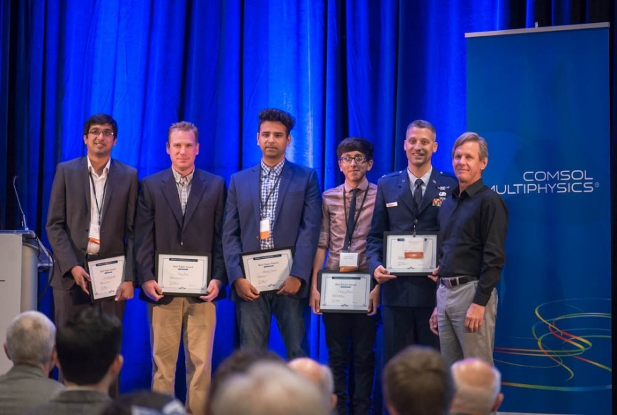 | From left to right: Fahd Mohiyaddin, Oak Ridge National Laboratory; Shaun Berry, MIT Lincoln Laboratory; Dipesh Niraula, University of Toledo; Cristian Morales, Boston University; Bryan Adomanis, Air Force Institute of Technology; Svante Littmarck, CEO and president of COMSOL.

About COMSOL
COMSOL is a global provider of simulation software for product design and research to technical enterprises, research labs, and universities. Its COMSOL Multiphysics® product is an integrated software environment for creating physics-based models and simulation apps. A particular strength is its ability to account for coupled or multiphysics phenomena. Add-on products expand the simulation platform for electromagnetics, structural, acoustics, fluid flow, heat transfer, and chemical applications. Interfacing tools enable the integration of COMSOL Multiphysics® simulations with all major technical computing and CAD tools on the CAE market. Simulation experts rely on the COMSOL Server™ product to deploy apps to their design teams, manufacturing departments, test laboratories, and customers throughout the world. Founded in 1986, COMSOL employs more than 450 people in 20 offices worldwide and extends its reach with a network of distributors.
~
COMSOL, COMSOL Multiphysics, LiveLink, and COMSOL Server are either registered trademarks or trademarks of COMSOL AB. For other trademark ownership, see www.comsol.com/trademarks.

