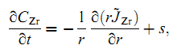
The is depond on the temperature
For T<T₀ 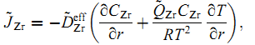,
For T>T₀ 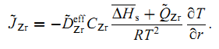,

The question is: how can I estimate T in the comsol when solving the heat equation.

