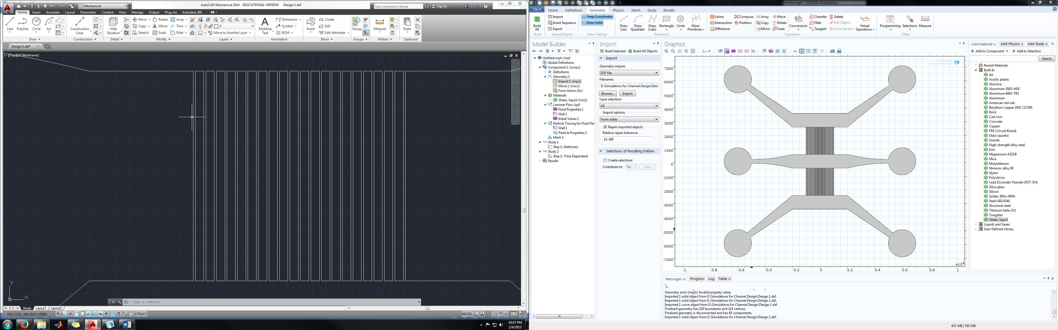

Channel Spacing– Converted to Solid

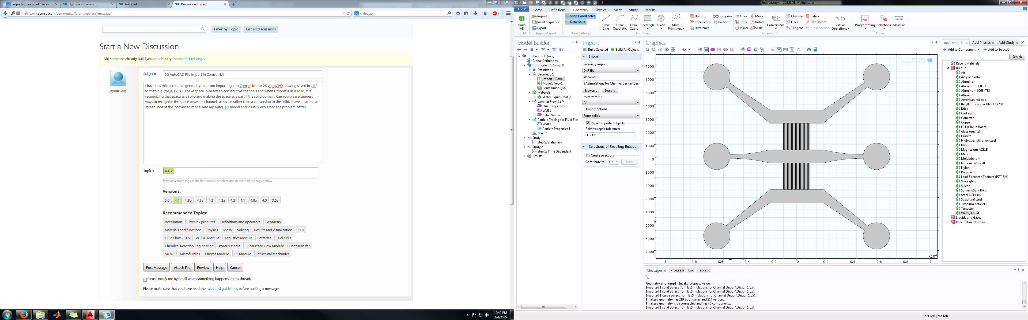

Channel Spacing– Converted to Solid