"step index fiber" model liblary using comsol old version (comsol version3.4)
standard result originally contains in the liblary
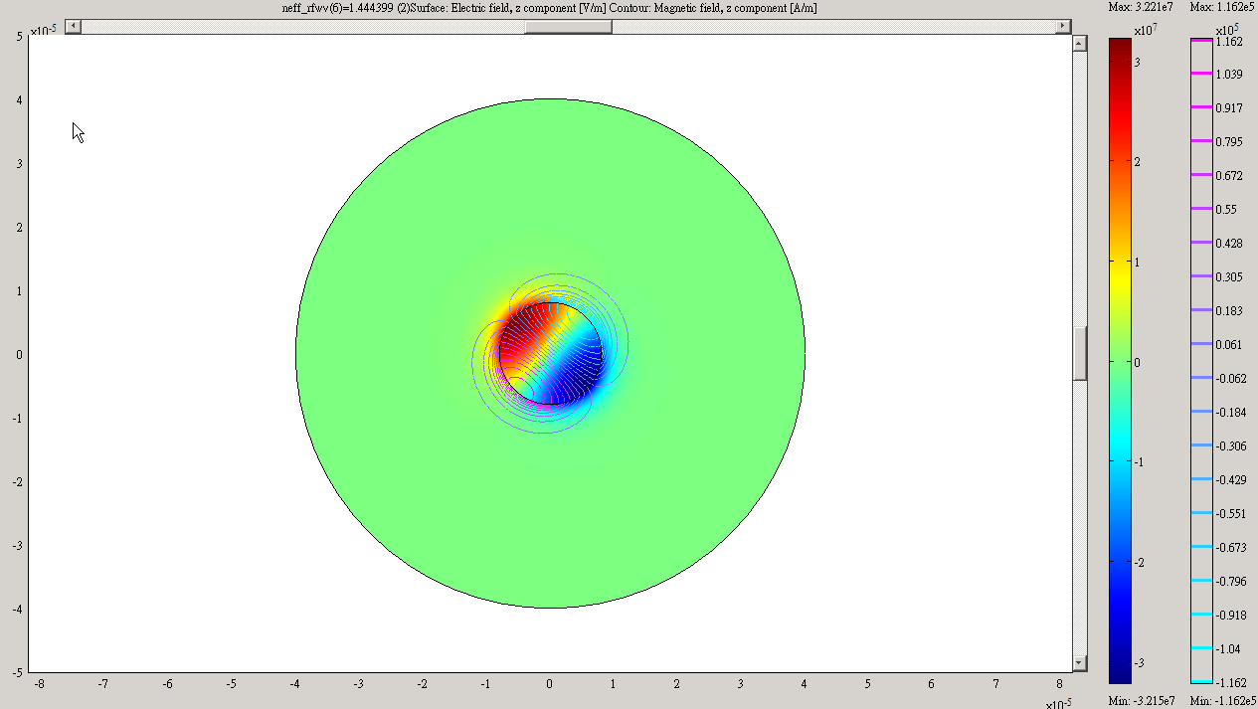

the file from comsol version3.4 without modifying any parameter after re-meshing and run
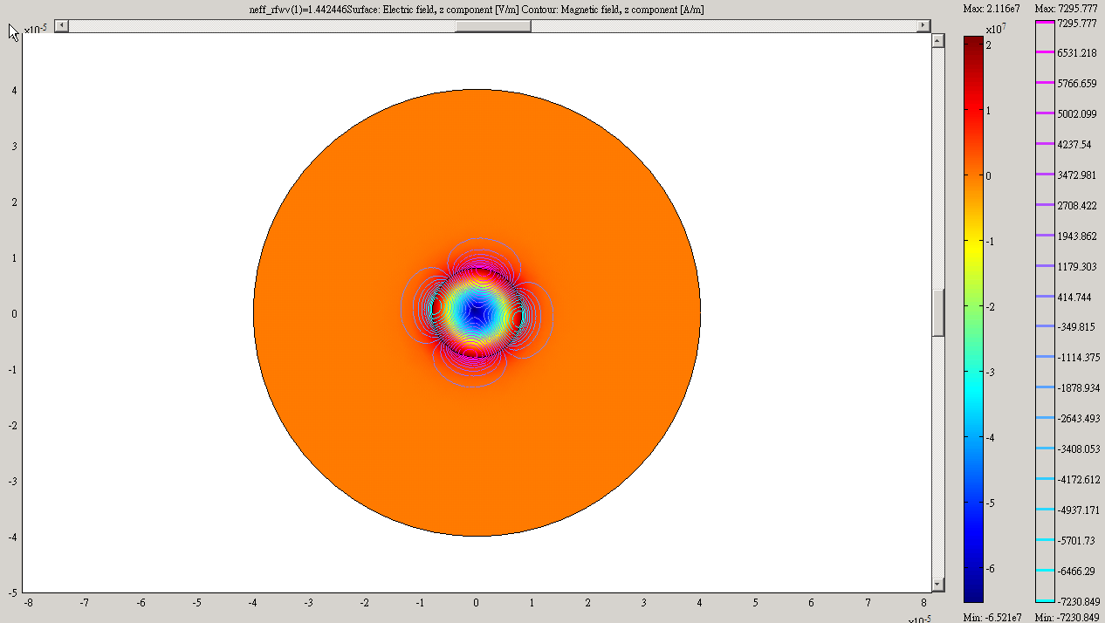

"step index fiber" model liblary using comsol old version (comsol version3.5a)
standard result originally contains in the liblary
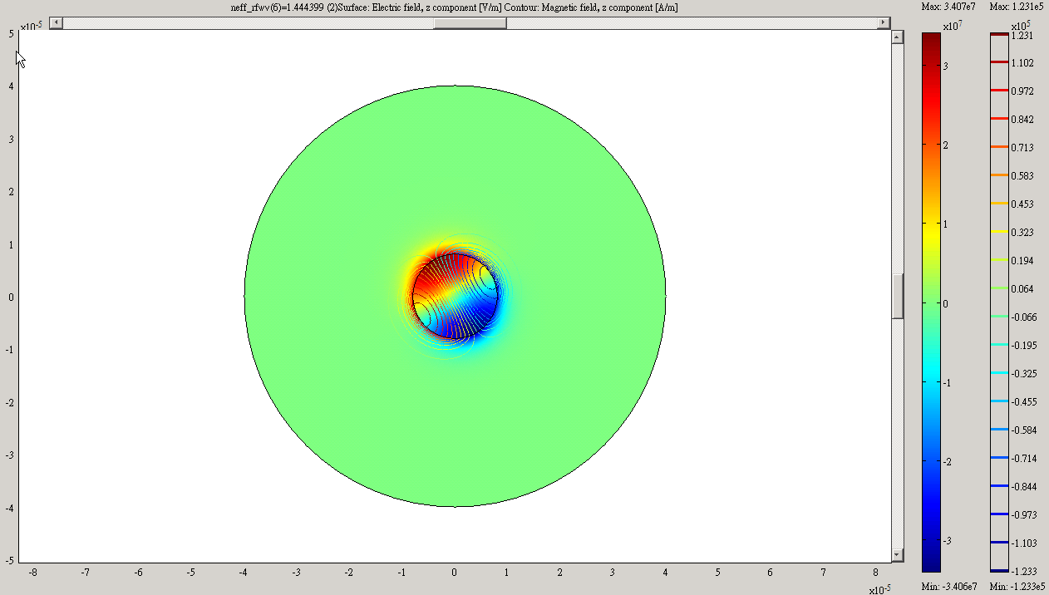

the file from comsol version3.5a without modifying any parameter after re-meshing and run
