Dear Ivar

Thank you for your unbelievable help .
I try to put time rang (0,0.001,0.01) and still get singularity
So I will give you all details of my model:
This is my model in 3D

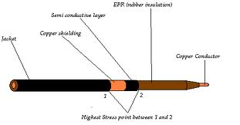
When I draw in 2D I will get as shown

Copper conductor at 16000V
Xlpe insulation
Semi conductor material
Point 1

- Semi conductor material is gounded
- The conductor is at voltage = 16000 an1(t[1/s]) (pulse train with freq=1000 and amplitude = 16kV)
- Heat generated is convected away to air
When we apply voltage with high frequency at the conductor --- high electric field will be induced and will be concentrated at the point 1 in the figure -- so that generating heat will be induced and our target is to get its temperature

